HA cluster configuration guide for SAP HANA on SUSE
This guide shows you how to deploy and configure a SUSE Enterprise Linux System (SLES) high-availability (HA) cluster for an SAP HANA 2.0 SPS 05 or later scale-up system on DELL RACK servers.
This WI includes the steps for:
- Configuring a Pacemaker cluster on SLES to manage the SAP systems and other resources during a failover
This WI also includes steps for configuring SAP HANA system replication but consult to the SAP Basis Team and SAP documentation for the definitive instructions.
The system that this guide deploys
Following this guide, you will deploy two SAP HANA Virtual Machines and set up an HA cluster on SLES. You Install each SAP HANA Servers on a different DELL RACK servers hosted in Different Rack within the same Datacenter (preferred to build in).
The deployed cluster includes the following functions and features:
- Two hosts, each with an instance of SAP HANA
- Synchronous SAP HANA system replication.
- The Pacemaker high-availability cluster resource manager.
- A STONITH and SBD fencing mechanism.
- Automatic restart of the failed instance as the new secondary instance.
Prerequisites
- Before you create the SAP HANA high availability cluster, make sure that the following prerequisites are met:
Server Configuration:
- Both servers are in individual RACK servers hosted in different RACKs
- Both Servers should be use individual Storage spaces
- Both servers should have Same amount of CPU and Memory.
- Both Servers should have 3 or 5 nos of 200MB shared LUNs for heartbeat purpose.
- Both servers reachable to their IDRAC console IP to perform STONITH action.
- IPMI feature is enabled in both IDRACs and svc_osfence account having privilege to login IDRAC console
- Both servers should deploy from Mylan Approved OS deployment procedure and required pre-requisites should meet based on the application requirement.
- Both the node configured with required mount points
- Disable IPv6 addressing in both server
High Level Diagram:
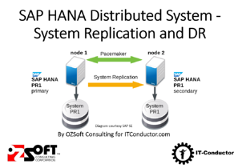
Checking the configuration of the servers and SAP HANA
- After the SAP HANA system deploys without errors, connect to each VM by using SSH.
- Change to the root user.
$ sudo su –
- At the command prompt, enter df -h. On each VM, ensure that you see the /hana directories, such as /hana/data.
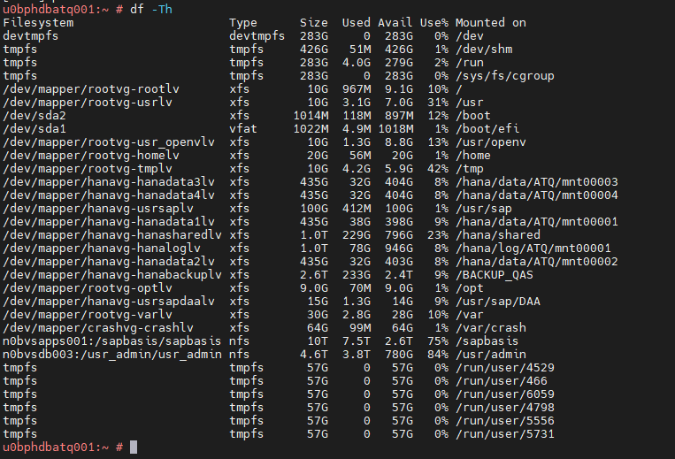
- Change to the SAP admin user
# su - atqadm
- Ensure that the SAP HANA services, such as hdbnameserver, hdbindexserver, and others, are running on the instance by entering the following command:
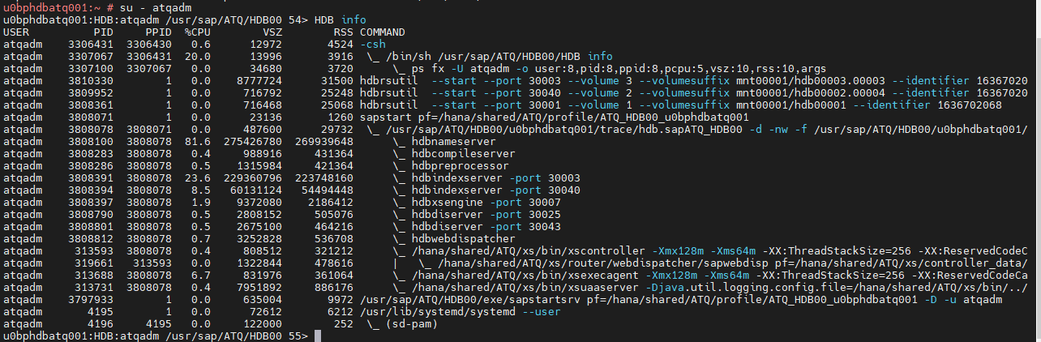
Disable SAP HANA autostart
For each SAP HANA instance in the cluster, make sure that SAP HANA autostart is disabled. For failovers, Pacemaker manages the starting and stopping of the SAP HANA instances in a cluster.
- On each host as atqadm, stop SAP HANA:
> HDB stop
- On each host, open the SAP HANA profile by using an editor, such as vi:
vi /usr/sap/ATQ/SYS/profile/ATQ_HDB00_u0bphdbatq001
- Set the Autostart property to 0:
Autostart=0
- Save the profile.
- On each host as atqadm, start SAP HANA:
> HDB start
Back up the databases
Create backups of your databases to initiate database logging for SAP HANA system replication and create a recovery point.
If you have multiple tenant databases in an MDC configuration, back up each tenant database.
The Deployment Manager template uses /hanabackup/data/SID as the default backup directory.
To create backups of new SAP HANA databases:
- On the primary host, switch to atqadm. Depending on your OS image, the command might be different.
sudo -i -u atqadm
- Create database backups:
- For a SAP HANA single-database-container system:
> hdbsql -t -u system -p <system-password> -i <inst-num> "backup data using file ('full')"
The following example shows a successful response from a new SAP HANA system:
0 rows affected (overall time 18.416058 sec; server time 18.414209 sec)
- For a SAP HANA multi-database-container system (MDC), create a backup of the system database as well as any tenant databases:
> hdbsql -t -d SYSTEMDB -u system -p <system-password> -i <inst_num> "backup data using file ('full')"
> hdbsql -t -d SID -u system -p <system-password> -i <inst-num> "backup data using file ('full')"
The following example shows a successful response from a new SAP HANA system:
0 rows affected (overall time 16.590498 sec; server time 16.588806 sec)
- Confirm that the logging mode is set to normal:
> hdbsql -u system -p <system-password> -i <inst_num> "select value from "SYS"."M_INIFILE_CONTENTS" where key='log_mode'"
You should see:
VALUE
"normal"
Enable SAP HANA system replication
As a part of enabling SAP HANA system replication, you need to copy the data and key files for the SAP HANA secure stores on the file system (SSFS) from the primary host to the secondary host. The method that this procedure uses to copy the files is just one possible method that you can use.
- On the primary host as atqadm, enable system replication:
u0bphdbatq001> hdbnsutil -sr_enable --name= u0bphdbatq001
- On the secondary host as atqadm, stop SAP HANA:
u0bphdbatq002> HDB stop
- On the primary host, using the same user account that you used to set up SSH between the host VMs, copy the key files to the secondary host. For convenience, the following commands also define an environment variable for your user account ID:
$ sudo cp /usr/sap/ATQ/SYS/global/security/rsecssfs ~/rsecssfs -r
$ sudo chown atqadm -R /home/atqadm/rsecssfs
$ scp -r rsecssfs atqadm@ u0bphdbatq002:rsecssfs
$ rm -r /home/atqadm/rsecssfs
- On secondary host, as the same user as the preceding step:
- Replace the existing key files in the rsecssfs directories with the files from the primary host and set the file permissions to limit access:
$ sudo rm /usr/sap/ATQ/SYS/global/security/rsecssfs/data/SSFS_ATQ.DAT
$ sudo rm /usr/sap/ATQ/SYS/global/security/rsecssfs/key/SSFS_ATQ.KEY
$ sudo cp /home/atqadm/rsecssfs/data/SSFS_ATQ.DAT \
/usr/sap/ATQ/SYS/global/security/rsecssfs/data/SSFS_ATQ.DAT
$ sudo cp /home/atqadm/rsecssfs/key/SSFS_ATQ.KEY \
/usr/sap/ATQ/SYS/global/security/rsecssfs/key/SSFS_ATQ.KEY
$ sudo chown atqadm:sapsys /usr/sap/ATQ/SYS/global/security/rsecssfs/data/SSFS_ATQ.DAT
$ sudo chown atqadm:sapsys \
/usr/sap/ATQ/SYS/global/security/rsecssfs/key/SSFS_ATQ.KEY
$ sudo chmod 644 \
/usr/sap/ATQ/SYS/global/security/rsecssfs/data/SSFS_ATQ.DAT
$ sudo chmod 640 \
/usr/sap/ATQ/SYS/global/security/rsecssfs/key/SSFS_ATQ.KEY
- Cleanup the files in your home directory.
$ rm -r /home/atqadm/rsecssfs
- As atqadm, register the secondary SAP HANA system with SAP HANA system replication:
> hdbnsutil -sr_register --remoteHost= u0bphdbatq001 --remoteInstance=<inst_num> \
--replicationMode=syncmem --operationMode=logreplay --name= u0bphdbatq002
- As atqadm, start SAP HANA:
> HDB start
Validating system replication
On the primary host as hatadm, confirm that SAP HANA system replication is active by running the following python script:
$ python /usr/sap/ATQ/HDB00/exe/python_support/systemReplicationStatus.py
If replication is set up properly, among other indicators, the following values are displayed for the xsengine, nameserver, and indexserver services:
- The Secondary Active Status is YES
- The Replication Status is ACTIVE
Also, the overall system replication status shows ACTIVE.
Install the cluster agents on both nodes
Complete the following steps on both nodes.
- As root user, Register the server with SLES and attached SUSE Linux Enterprise Server for SAP Applications License to the server by,
[root@ u0bphdbatq001 ~]# SUSEConnect -r 40A9CCD1E4841C -e mylaninfraunix@mylan.com -p "SLES_SAP/15.1-0/x86_64
Registering system to SUSE Customer Center

Updating system details on https://scc.suse.com ...

Activating sle-module-sap-applications 15.1 x86_64 ...
-> Adding service to system ...
-> Installing release package ...

Successfully registered system
u0bphdbatq001:~ # SUSEConnect -s
[{"identifier":"SLES_SAP","version":"15.2","arch":"x86_64","status":"Registered","regcode":"85B05E07715BA6D5","starts_at":"2021-07-09 00:00:00 UTC","expires_at":"2026-07-09 00:00:00 UTC","subscription_status":"ACTIVE","type":"oem"},{"identifier":"sle-module-basesystem","version":"15.2","arch":"x86_64","status":"Registered"},{"identifier":"sle-module-desktop-applications","version":"15.2","arch":"x86_64","status":"Registered"},{"identifier":"sle-module-server-applications","version":"15.2","arch":"x86_64","status":"Registered"},{"identifier":"sle-ha","version":"15.2","arch":"x86_64","status":"Registered","regcode":"85B05E07715BA6D5","starts_at":"2021-07-09 00:00:00 UTC","expires_at":"2026-07-09 00:00:00 UTC","subscription_status":"ACTIVE","type":"oem"},{"identifier":"sle-module-sap-applications","version":"15.2","arch":"x86_64","status":"Registered"}]
- Ensure, systems have the latest available patches applied, refer attachment for complete output
u0bphdbatq001:~ # zypper patch
Refreshing service 'Basesystem_Module_15_SP2_x86_64'.
Refreshing service 'Desktop_Applications_Module_15_SP2_x86_64'.
Refreshing service 'SAP_Applications_Module_15_SP2_x86_64'.
Refreshing service 'SUSE_Linux_Enterprise_High_Availability_Extension_15_SP2_x86_64'.
Refreshing service
~
~
The following 16 patterns are going to be upgraded:
32bit apparmor apparmor-32bit base base-32bit basesystem basic_desktop enhanced_base
enhanced_base-32bit minimal_base minimal_base-32bit sap_server x11 x11-32bit x11_enhanced
x11_enhanced-32bit

The following patch requires a system reboot:
SUSE-SLE-Module-Basesystem-15-SP2-2021-2810

112 packages to upgrade.
Overall download size: 118.4 MiB. Already cached: 0 B. After the operation, 10.4 KiB will be
freed.

Note: System reboot required.
Continue? [y/n/v/...? shows all options] (y): y
Retrieving package cpio-2.12-3.9.1.x86_64 (1/112), 86.3 KiB (163.2 KiB unpacked)
~
~
Executing %posttrans scripts ...........................................................[done]
Warning: One of the installed patches requires a reboot of your machine. Reboot as soon as possible.
There are running programs which still use files and libraries deleted or updated by recent upgrades. They should be restarted to benefit from the latest updates. Run 'zypper ps -s' to list these programs.

Since the last system boot core libraries or services have been updated.
Reboot is suggested to ensure that your system benefits from these updates.

- Ensure HA packages installed on the both node by,
u0bphdbatq001:~ # zypper in -t pattern ha_sles
Refreshing service 'Basesystem_Module_15_SP2_x86_64'.
Refreshing service 'Desktop_Applications_Module_15_SP2_x86_64'.
Refreshing service 'SAP_Applications_Module_15_SP2_x86_64'.
Refreshing service 'SUSE_Linux_Enterprise_High_Availability_Extension_15_SP2_x86_64'.
Refreshing service 'SUSE_Linux_Enterprise_Server_for_SAP_Applications_15_SP2_x86_64'.
~
……..
~
The following NEW pattern is going to be installed:
ha_sles

The following 15 recommended packages were automatically selected:
cluster-md-kmp-default crmsh dlm-kmp-default fence-agents hawk2 libdlm libvirt-bash-completion libvirt-client ocfs2-kmp-default ocfs2-tools resource-agents ruby2.5-rubygem-byebug
ruby2.5-rubygem-puma ruby2.5-rubygem-sass-rails sbd

The following package requires a system reboot:
kernel-default-5.3.18-24.78.1

125 new packages to install.
Overall download size: 99.1 MiB. Already cached: 0 B. After the operation, additional 400.4 MiB will be used.

Note: System reboot required.
Continue? [y/n/v/...? shows all options] (y): y
Retrieving package libnetfilter_cthelper0-1.0.0-1.21.x86_64 (1/125), 13.0 KiB ( 14.4 KiB unpacked)
Retrieving: libnetfilter_cthelper0-1.0.0-1.21.x86_64.rpm ..................................................................................................................................[done]
~
…..
~
dracut: root=/dev/mapper/rootvg-rootlv rootfstype=xfs rootflags=rw,relatime,attr2,inode64,logbufs=8,logbsize=32k,sunit=512,swidth=512,noquota
dracut: *** Creating image file '/boot/initrd-5.3.18-24.78-default' ***
dracut: *** Creating initramfs image file '/boot/initrd-5.3.18-24.78-default' done ***

Executing %posttrans scripts ..............................................................................................................................................................[done]

- Set password for the hacluster user, which is installed as part of the packages:
# passwd hacluster
Specify a password for hacluster at the prompts. Refer cyperark site for password

- In the /etc/hosts file, add the full host name and the internal IP addresses of both hosts in the cluster. For example:
127.0.0.1 localhost
::1 localhost ipv6-localhost ipv6-loopback

fe00::0 ipv6-localnet

ff00::0 ipv6-mcastprefix
ff02::1 ipv6-allnodes
ff02::2 ipv6-allrouters
ff02::3 ipv6-allhosts
172.20.34.99 u0bphdbatq002.myl.com u0bphdbatq002
172.20.34.98 u0bphdbatq001.myl.com u0bphdbatq001
Cluster Base configuration :
- We are using physical server as a cluster node, so configure hardware-based watchdog device.
  - We are using DELL server with Intel based, we have to load "iTCO_wdt" module to kernel. To verify loaded module by
u0bphdbatq001:~ # lsmod | grep -e dog -e wdt
iTCO_wdt 16384 0
iTCO_vendor_support 16384 1 iTCO_wdt
  - If the module not loaded in the kernel, load it by,
u0bphdbatq001:~ # modprobe iTCO_wdt
  - In order to automate loading of the right watchdog module, it has to be included into the boot process. Append the basename of the right module to the content of the INITRD_MODULES variable in /etc/sysconfig/kernel
u0bphdbatq001:~ # grep “INITRD_MODULES” /etc/sysconfig/kernel
INITRD_MODULES="iTCO_wdt"
  - Recreate/update the initrd by,
u0bphdbatq001:~ # mkinitrd

Note:refer output in comments

- Get 3 or 5 shared LUN with size of 200MB from storage team. Ensure SBD LUNS are visible at both server and identify the path
u0bphdbatq001:~ # ls -l /dev/disk/by-id/scsi-36*
lrwxrwxrwx 1 root root 10 Sep 2 21:47 /dev/disk/by-id/scsi-360000970000197901040533030303031 -> ../../dm-6
lrwxrwxrwx 1 root root 10 Sep 2 21:47 /dev/disk/by-id/scsi-360000970000197901040533030314541 -> ../../dm-3
lrwxrwxrwx 1 root root 10 Sep 2 21:47 /dev/disk/by-id/scsi-360000970000197901040533030314542 -> ../../dm-4
lrwxrwxrwx 1 root root 10 Sep 2 21:47 /dev/disk/by-id/scsi-360000970000197901040533030314543 -> ../../dm-5
lrwxrwxrwx 1 root root 9 Sep 2 21:47 /dev/disk/by-id/scsi-362cea7f0ac1725002893aa04170ddc98 -> ../../sda
lrwxrwxrwx 1 root root 10 Sep 2 21:47 /dev/disk/by-id/scsi-362cea7f0ac1725002893aa04170ddc98-part1 -> ../../sda1
lrwxrwxrwx 1 root root 10 Sep 2 21:47 /dev/disk/by-id/scsi-362cea7f0ac1725002893aa04170ddc98-part2 -> ../../sda2
lrwxrwxrwx 1 root root 10 Sep 2 21:47 /dev/disk/by-id/scsi-362cea7f0ac1725002893aa04170ddc98-part3 -> ../../sda3
lrwxrwxrwx 1 root root 10 Sep 2 21:47 /dev/disk/by-id/scsi-362cea7f0ac1725002893aa04170ddc98-part4 -> ../../sda4
lrwxrwxrwx 1 root root 10 Sep 2 21:47 /dev/disk/by-id/scsi-362cea7f0ac1725002893aa122ca8c63a -> ../../dm-7
lrwxrwxrwx 1 root root 11 Sep 2 21:47 /dev/disk/by-id/scsi-362cea7f0ac1725002893aa122ca8c63a-part1 -> ../../dm-14

- As root on 1st node, create cluster using
u0bphdbatq001:~ # ha-cluster-init -u \
-s /dev/disk/by-id/scsi-360000970000197901040533030314541 \
-s /dev/disk/by-id/scsi-360000970000197901040533030314542 \
-s /dev/disk/by-id/scsi-360000970000197901040533030314543
- Ensure SBD devices added in cluster
u0bphdbatq001:~ # tail /etc/sysconfig/sbd
#
SBD_MOVE_TO_ROOT_CGROUP=auto
## Type: string
## Default: ""
#
# Additional options for starting sbd
#
SBD_OPTS=
SBD_DEVICE="/dev/disk/by-id/scsi-360000970000197901040533030314541;/dev/disk/by-id/scsi-360000970000197901040533030314542;/dev/disk/by-id/scsi-360000970000197901040533030314543"

u0bphdbatq001:~ # sbd -d /dev/disk/by-id/scsi-360000970000197901040533030314541 -d /dev/disk/by-id/scsi-360000970000197901040533030314542 -d /dev/disk/by-id/scsi-360000970000197901040533030314543 list
0 u0bphdbatq001 clear
0 u0bphdbatq001 clear
0 u0bphdbatq001 clear
- Check Check the corosync status:
u0bphdbatq001:~ # corosync-cfgtool -s
Printing ring status.
Local node ID 1
RING ID 0
id = 172.20.34.98
status = ring 0 active with no faults
u0bphdbatq001:~ #
- As root on 2nd node, repeat step 1 to 3 , Then Join this node to existing cluster by,
u0bphdbatq002:~ # ha-cluster-join
- View the corosync configuration specific to a two node cluster
u0bphdbatq002:~ # tail /etc/corosync/corosync.conf
quorum {
# Enable and configure quorum subsystem (default: off)
# see also corosync.conf.5 and votequorum.5
provider: corosync_votequorum
expected_votes: 2
two_node: 1
}

u0bphdbatq002:~ # crm status
Cluster Summary:
* Stack: corosync
* Current DC: u0bphdbatq001 (version 2.0.4+20200616.2deceaa3a-3.9.1-2.0.4+20200616.2deceaa3a) - partition with quorum
* Last updated: Fri Sep 3 01:51:37 2021
* Last change: Fri Sep 3 01:48:32 2021 by hacluster via crmd on u0bphdbatq001
* 2 nodes configured
* 2 resource instances configured

Node List:
* Online: [ u0bphdbatq001 u0bphdbatq002 ]

Full List of Resources:
* admin-ip (ocf::heartbeat:IPaddr2): Started u0bphdbatq001
* stonith-sbd (stonith:external/sbd): Started u0bphdbatq001
- Change the start mode for sbd. Setting this to "clean" will only allow sbd to start if it was not previously fenced. The default value of SBD_STARTMODE is set to always. This means even if a node was previously fenced it will rejoin the cluster
u0bphdbatq001:~ # vi /etc/sysconfig/sbd
u0bphdbatq001:~ # grep STARTMODE /etc/sysconfig/sbd
SBD_STARTMODE=clean
Set up fencing
- Configure IDRAC for initial settings:
  - Login IDRAC of DELL server and enable IPMI access over LAN
iDRAC Settings >
Connectivity >
Network >
IPMI Settings:
In IPMI settings, set below and click apply
Enable IPMI Over LAN is enabled
Channel Privilege Level Limit is Administrator
Encryption Key* is 0000000000000000000000000000000000000000
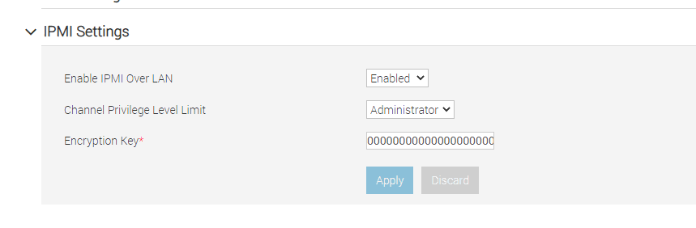
- create a new user with the username “svc_osfence” and password (refer it is cyperark portal).
iDRAC Settings >
users>
Local Users>
ADD > Add new user page will open
The privilege of the user svc_osfence is Read-only and select the check box login to IDRAC.
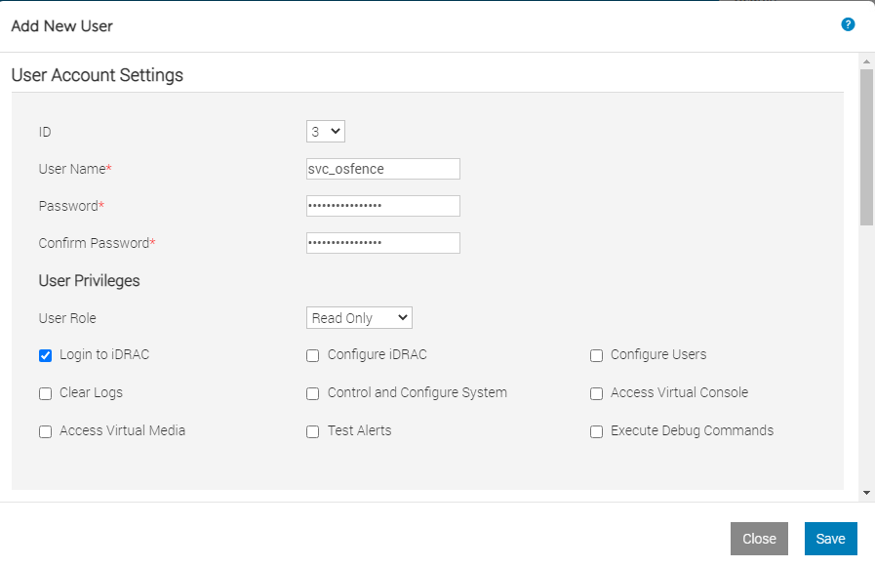In the advanced settings in the add new user page, under IPMI user privileges, set Lan privilege to Administrator and save to create the user account.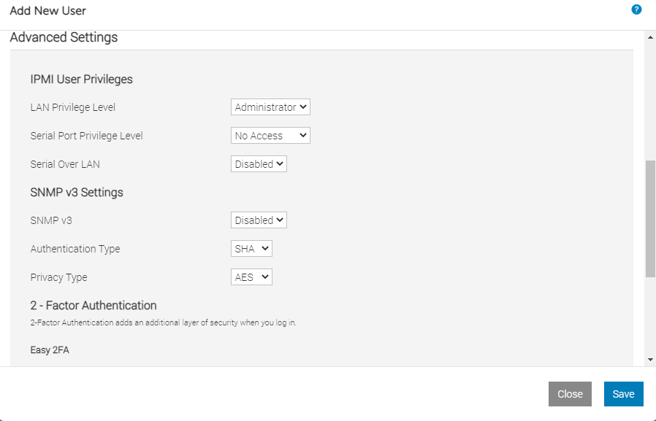
- Login to server SERVER and ensure svc_fence user can access the IDRAC.
u0bphdbatq001:~ # ipmitool -I lanplus -H 172.20.81.245 -U svc_osfence -P '**********' -y 0000000000000000000000000000000000000000 -v chassis status

- Keep the Cluster into Maintenance mode during adding cluster resources
u0bphdbatq001:~ # crm configure property maintenance-mode="true"

- Configure stonith resource in cluster
  - Create a text file /root/hacluster/stonith.txt and append below lines
u0bphdbatq001:~ # cat /root/hacluster/stonith.txt
primitive STONITH_IPMI_ATQ01 stonith:external/ipmi \
params interface=lanplus ipaddr=172.20.81.245 \
userid=svc_osfence passwd="******" ipmitool="/usr/bin/ipmitool" \
pcmk_host_list=u0bphdbatq001 hostname=u0bphdbatq001-imm \
op start interval=0 timeout=20 \
op stop interval=0 timeout=15 \
op monitor interval=3600 timeout=20 \
primitive STONITH_IPMI_ATQ02 stonith:external/ipmi \
params interface=lanplus ipaddr=172.20.81.246 \
userid=svc_osfence passwd="******" ipmitool="/usr/bin/ipmitool" \
pcmk_host_list=u0bphdbatq002 hostname=u0bphdbatq002-imm \
op start interval=0 timeout=20 \
op stop interval=0 timeout=15 \
op monitor interval=3600 timeout=20

  - Update the existing configuration with above stonith resource by
u0bphdbatq001:~ # crm configure load update /root/hacluster/stonith.txt

VIP configuration:
- Floating IP – It should be production or end user communication IP address
- VLAN of the floating IP was configured at Both Node NIC
- Better to choose same VLAN as persistent IP
- Add the IP which needs to be high-available to the cluster
- Configure the VIP or Floating IP in Cluster:
  - Create a text file /root/hacluster/vip.txt and append below lines
u0bphdbatq001:~ # cat /root/hacluster/vip.txt
primitive VIP_ATQ_HDB00 IPaddr2 \
params ip=172.20.34.88 \
op monitor interval=10 timeout=20
  - Update the existing configuration with above resource by
u0bphdbatq001:~ # crm configure load update /root/hacluster/vip.txt

Configure the SAP HANA HA/DR provider:
- Install the SAPHanaSR package On both hosts:
u0bphdbatq001:~ # zypper in SAPHanaSR
- As root, open the global.ini file for editing:
# vi /hana/shared/ATQ/global/hdb/custom/config/global.ini
Add the following definitions to the global.ini file:
[[ha_dr_provider_SAPHanaSR]
provider = SAPHanaSR
path = /usr/share/SAPHanaSR
execution_order = 1
[trace]
ha_dr_saphanasr = info
- As root, create a sudo configuration file to allow the hook script to update the node attributes when the srConnectionChanged()hook is called:
u0bphdbatq001:~ # vi /etc/sudoers.d/atqadm
# SAPHanaSR-ScaleUp entries for writing srHook cluster attribute
atqadm ALL=(ALL) NOPASSWD: /usr/sbin/crm_attribute -n hana_atq_site_srHook_*
- The SAPHanaTopology resource gets the status and configuration of HANA System Replication on the nodes. It also checks the SAP host agent.
  - Create a text file /root/hacluster/vip.txt and append below lines
u0bphdbatq001:~ # cat /root/hacluster/ saphanatopology.txt
# SAPHanaTopology resource configuration
primitive Topology_ATQ_HDB00 ocf:suse:SAPHanaTopology \
op monitor interval="10" timeout="600" \
op start interval="0" timeout="600" \
op stop interval="0" timeout="300" \
params SID="ATQ" InstanceNumber="00"\
clone Topology_ATQ_HDB00_clone Topology_ATQ_HDB00 \
meta clone-node-max="1" interleave="true"
  - Update the existing configuration with above resource by
u0bphdbatq001:~ # crm configure load update /root/hacluster/ saphanatopology.txt

- The SAPHana resource agent manages the databases that are configured for SAP HANA system replication.
  - Create a text file /root/hacluster/vip.txt and append below lines
u0bphdbatq001:~ # cat /root/hacluster/ saphanadb.txt
# SAPHana resource configuration
primitive SAP_HDB_ATQ ocf:suse:SAPHana \
op start interval="0" timeout="3600" \
op stop interval="0" timeout="3600" \
op promote interval="0" timeout="3600" \
op monitor interval="60" role="Master" timeout="700" \
op monitor interval="61" role="Slave" timeout="700" \
params SID="ATQ" InstanceNumber="00" \
PREFER_SITE_TAKEOVER="true" \
DUPLICATE_PRIMARY_TIMEOUT="7200" AUTOMATED_REGISTER="false"
ms SAP_HDB_ATQ_clone SAP_HDB_ATQ \
meta clone-max="2" clone-node-max="1" interleave="true"
  - Update the existing configuration with above resource by
u0bphdbatq001:~ # crm configure load update /root/hacluster/ saphanadb.txt

- You create constraints to define which services need to start first, and which services need to run together on the same host. For example, the IP address must be on the same host as the primary HANA instance.
  - Create a text file /root/hacluster/constraints.txt and append below lines
u0bphdbatq001:~ # cat /root/hacluster/constraints.txt
# Two constraints for VIP_ATQ_HDB00 and start order for SAP_HDB_ATQ and
Topology_ATQ_HDB00 resources
colocation SAPHDBATQ_VIP_COLOCATION 2000:
VIP_ATQ_HDB00:Started \
SAP_HDB_ATQ_clone:Master
order TOPOLOGY_SAPHDBATQ_ORDER Optional:
Topology_ATQ_HDB00_clone \
SAP_HDB_ATQ_clone
  - Update the existing configuration with above resource by
u0bphdbatq001:~ # crm configure load update /root/hacluster/ constraints.txt
- Remove cluster from Maintenance by,
u0bphdbatq001:~ # crm configure property maintenance-mode="false"
- Check the cluster status by
u0bphdbatq001:~ # crm status
Cluster Summary:
* Stack: corosync
* Current DC: u0bphdbatq002 (version 2.0.4+20200616.2deceaa3a-3.9.1-2.0.4+20200616.2deceaa3a) - partition with quorum
* Last updated: Fri Jan 21 06:55:12 2022
* Last change: Fri Jan 21 06:54:16 2022 by root via crm_attribute on u0bphdbatq001
* 2 nodes configured
* 10 resource instances configured

Node List:
* Online: [ u0bphdbatq001 u0bphdbatq002 ]

Full List of Resources:
* stonith-sbd (stonith:external/sbd): Started u0bphdbatq001
* Clone Set: Topology_ATQ_HDB00_clone [Topology_ATQ_HDB00]:
* Started: [ u0bphdbatq001 u0bphdbatq002 ]
* Clone Set: SAP_HDB_ATQ_clone [SAP_HDB_ATQ] (promotable):
* Masters: [ u0bphdbatq001 ]
* Slaves: [ u0bphdbatq002 ]
* VIP_ATQ_HDB00 (ocf::heartbeat:IPaddr2): Started u0bphdbatq001
* Clone Set: c-HDBATQCLST_FAILOVER_ALERT [HDBATQCLST_FAILOVER_ALERT]:
* Started: [ u0bphdbatq001 u0bphdbatq002 ]
* STONITH_IPMI_ATQ01 (stonith:external/ipmi): Started u0bphdbatq002
* STONITH_IPMI_ATQ02 (stonith:external/ipmi): Started u0bphdbatq001

Test failover
- Stop hana database in both node
- As the root test the fencing using the following command:
# crm node fence node02
Prepare the cluster before adding resources
Set the cluster into maintenance mode
u0bphdbatq001:~ # crm configure property maintenance-mode=true
u0bphdbatq001:~ # crm status
Cluster Summary:
* Stack: corosync
* Current DC: u0bphdbatq002 (version 2.0.4+20200616.2deceaa3a-3.9.1-2.0.4+20200616.2deceaa3a) - partition with quorum
* Last updated: Fri Sep 3 03:50:20 2021
* Last change: Fri Sep 3 03:50:08 2021 by root via cibadmin on u0bphdbatq001
* 2 nodes configured
* 2 resource instances configured

*** Resource management is DISABLED ***
The cluster will not attempt to start, stop or recover services

Node List:
* Online: [ u0bphdbatq001 u0bphdbatq002 ]

Full List of Resources:
* admin-ip (ocf::heartbeat:IPaddr2): Started u0bphdbatq002 (unmanaged)
* stonith-sbd (stonith:external/sbd): Started u0bphdbatq002 (unmanaged)

